
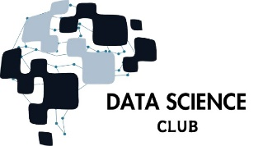

DATAFLIX

Date: 15-sept 2025 Event Report

 Basic details of Event :

→ Date of event - 15/09/2025
→ Timing of Event - 9:30AM to 4:00 PM
→ Faculty Coordinator - Prof. Nishit Kotak




→ Students Participants - Sem:1, 3, 5 of degree and diploma students of
branch Degree- ICT, Diploma-ICT

→ Total No. of Students – 68

Event Flow:

Binge the Data is a storytelling-meets-analytics challenge where students transform popular entertainment into an insight-rich e-book using data science tools and
techniques.
➔ Early Levels (Team Formation & Theme Selection): Teams of 2-3 students pick a unique theme—Web Series, Movies, TV Serials, or Cartoons—and justify why it was chosen.

➔ Intermediate Levels (Data Collection & Analysis): Teams extract and analyze data such as timelines, character networks, themes, sentiments, and audience engagement, using tools like Python, Power BI, or Tableau.

➔ Final Level (E-Book & Presentation): Each team compiles findings into a visually appealing, story-like Insight e-Book with dashboards, external data comparisons, and key insights. Teams present their work to a judging panel of professors, industry experts, and media professionals.

➔ There will be no elimination

➔ The diversity of themes ensures that participants can explore data storytelling across multiple genres, while the e-book structure, visual dashboards, and
curated insights maintain a balance of creativity, technical rigor, and industry relevance.




 Student list participated in the event (Round-1):

- Round-1 Theme selection using cards: Web Series, Movies, TV shows and cartoons.
- Round-2 We will also be adding a head start where you will be asking questions related to data science to your team and if the answers are correct you will get the point; if not negative marks will be given.
- Collect structured/unstructured data (scripts, transcripts, ratings, reviews, dialogues, metadata).
- Teams can use any AI they want
- Clean and preprocess using Excel, Python, or R.
- Draft initial visualizations (charts, plots, dashboards).

Round-3 Compile all findings into a structured Insight e-Book.
- Incorporate interactive dashboards, infographics, and storytelling.
- Teams present their work to a panel of professors, industry experts, and media professionals.
- Winning teams decided based on judging criteria (depth of analysis, creativity, storytelling, visualization, and presentation).

Outcomes of DataFlix: Binge the Data

Practical Exposure – Students got hands-on experience in the complete data workflow: data collection, cleaning, preprocessing, analysis, and visualization.

- Visualization & Storytelling Skills – Participants learned to create dashboards (Power BI/Tableau) and present insights in a storytelling format using e-books.
- Teamwork & Collaboration – The event enhanced collaboration, problem-solving, and interdisciplinary teamwork among participants.
- Applied Analytics – Students were able to connect entertainment data (movies, web series, TV shows, cartoons) with real-world datasets to derive meaningful insights.
- Industry-Relevant Practice – The challenge prepared students for industry-like tasks such as dashboard creation, analytical reporting, and data storytelling.
- Creativity & Innovation – Participants combined technical rigor with creativity by designing visually engaging dashboards and e-books.
- Confidence in Presentation – Through final presentations before faculty, industry experts, and media professionals, students gained confidence in communicating insights effectively.




Participants List:

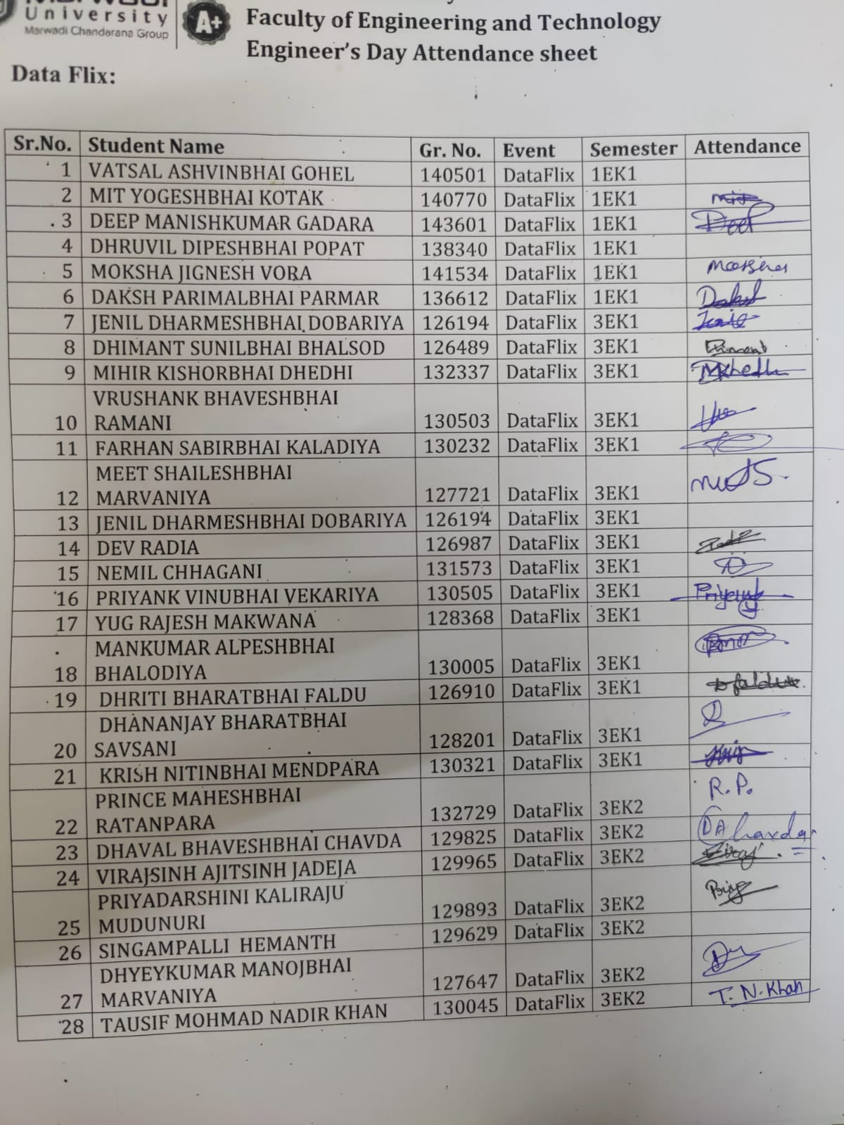

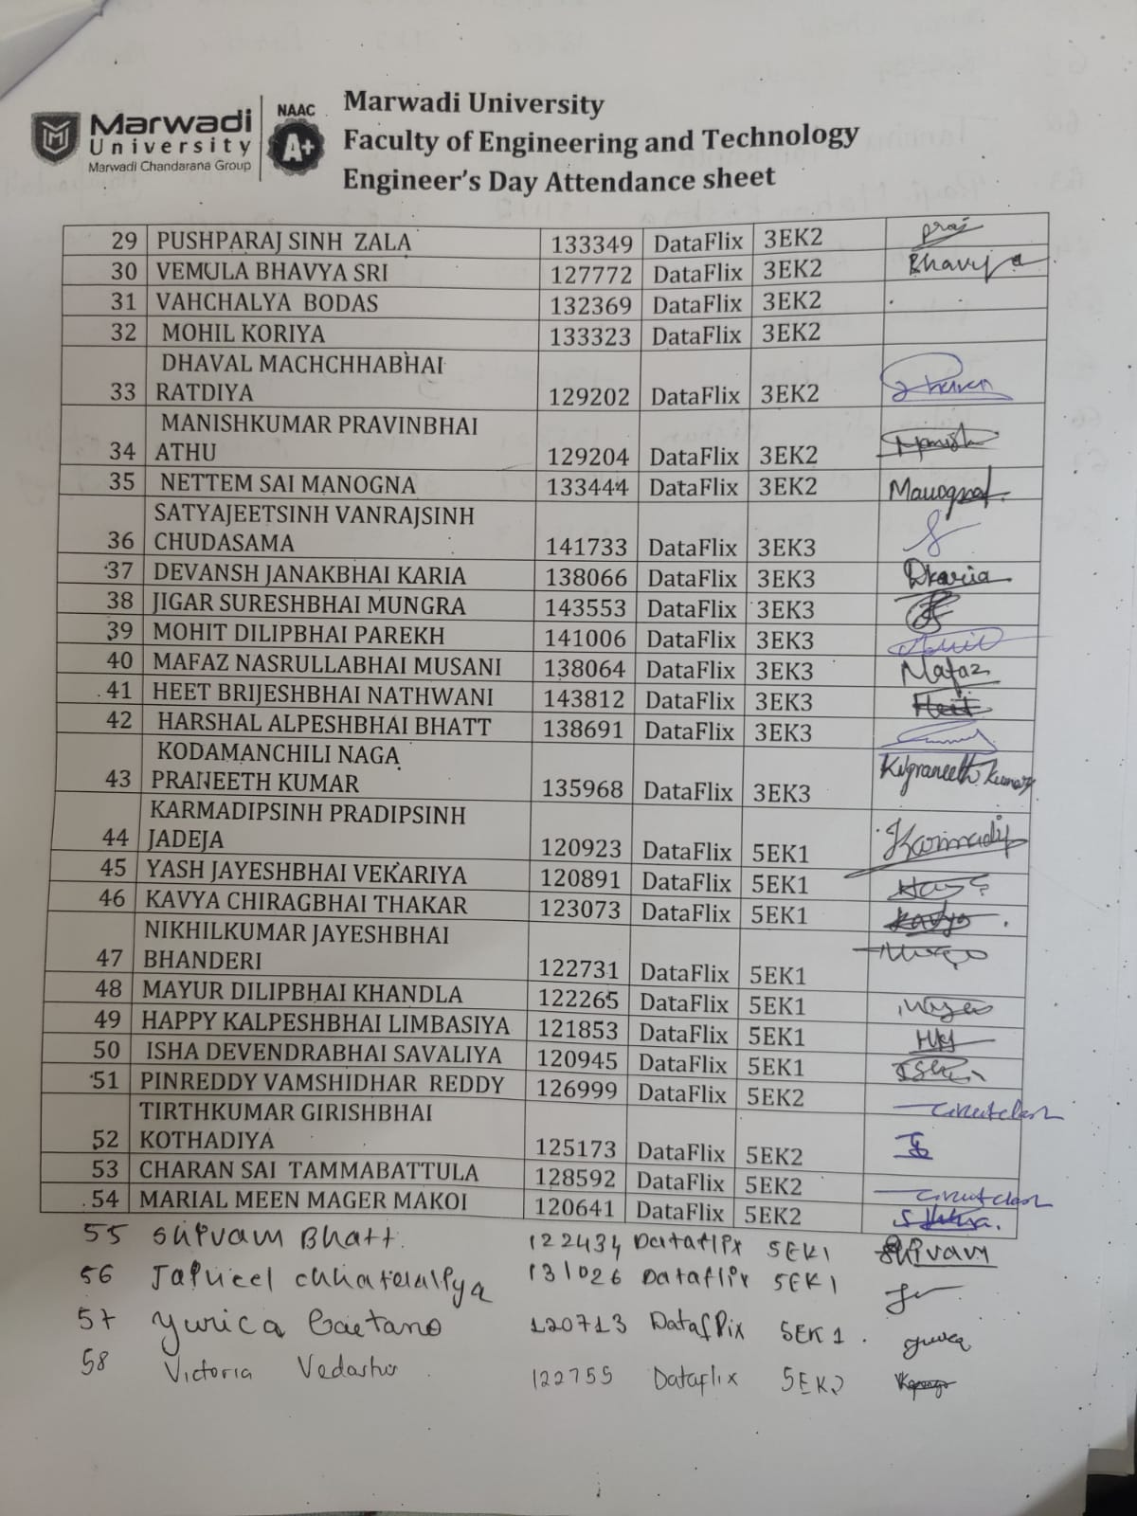
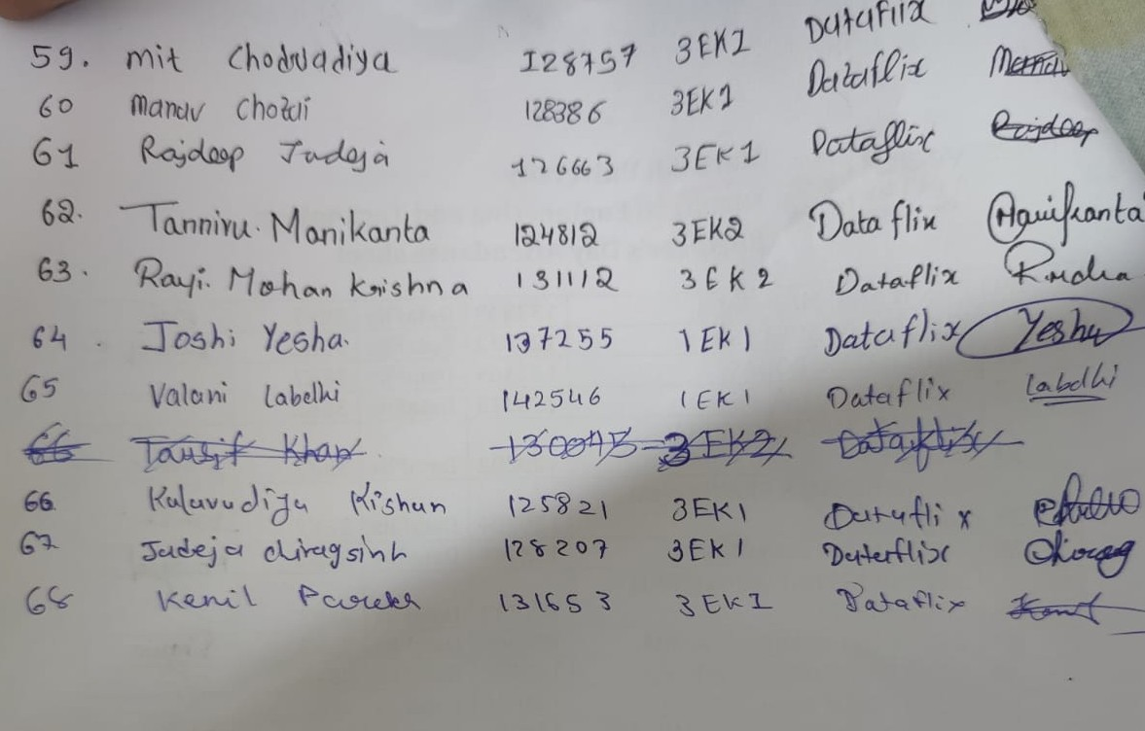

Event Photos :

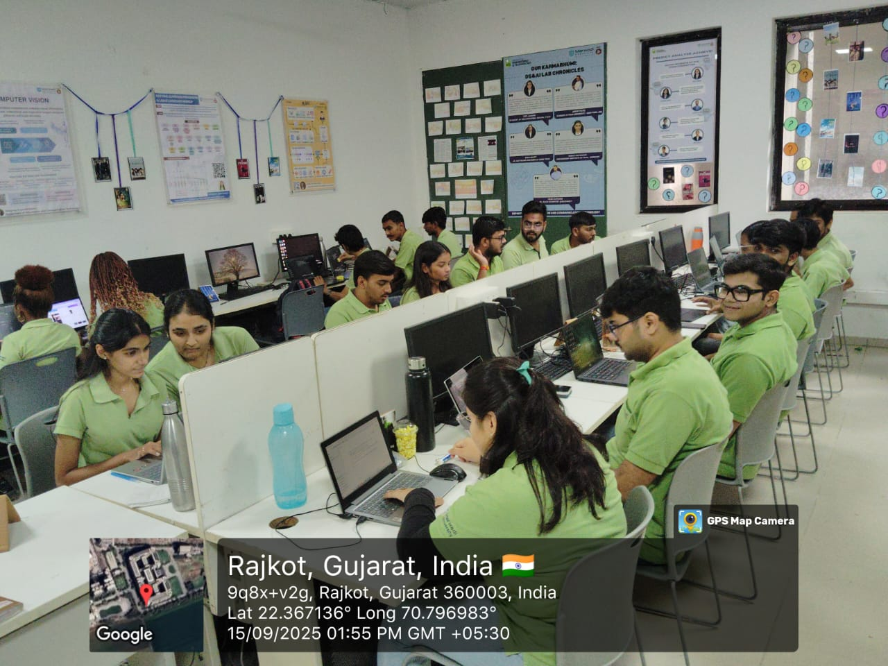

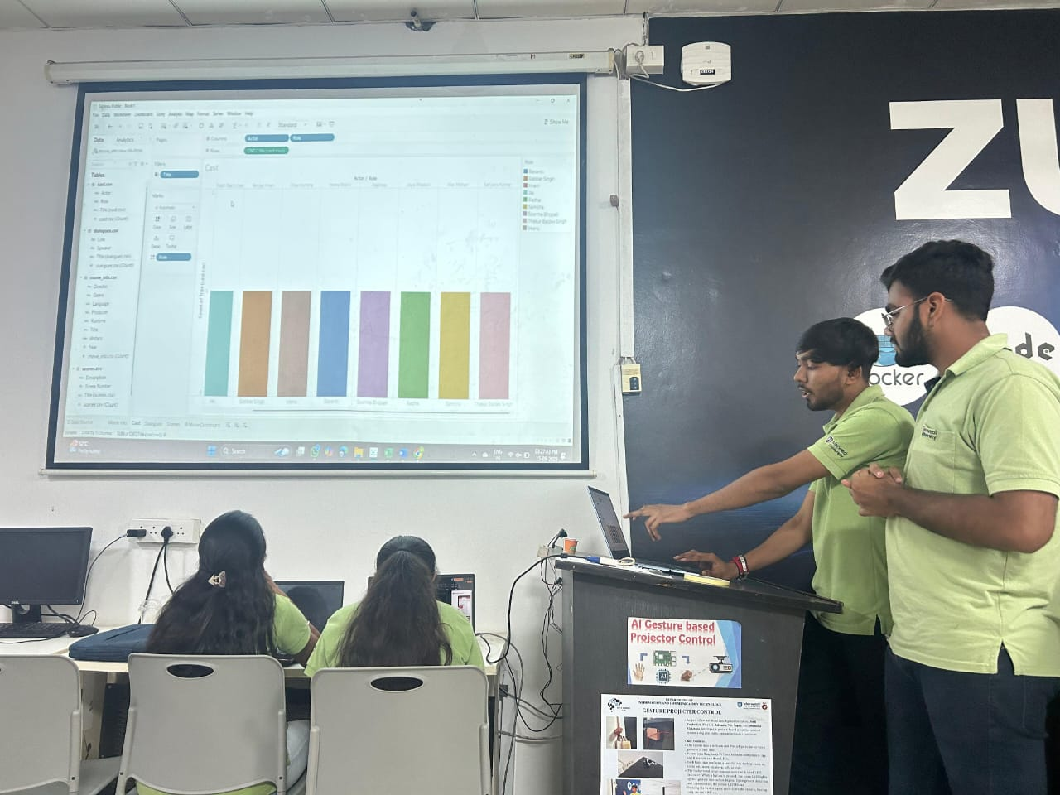

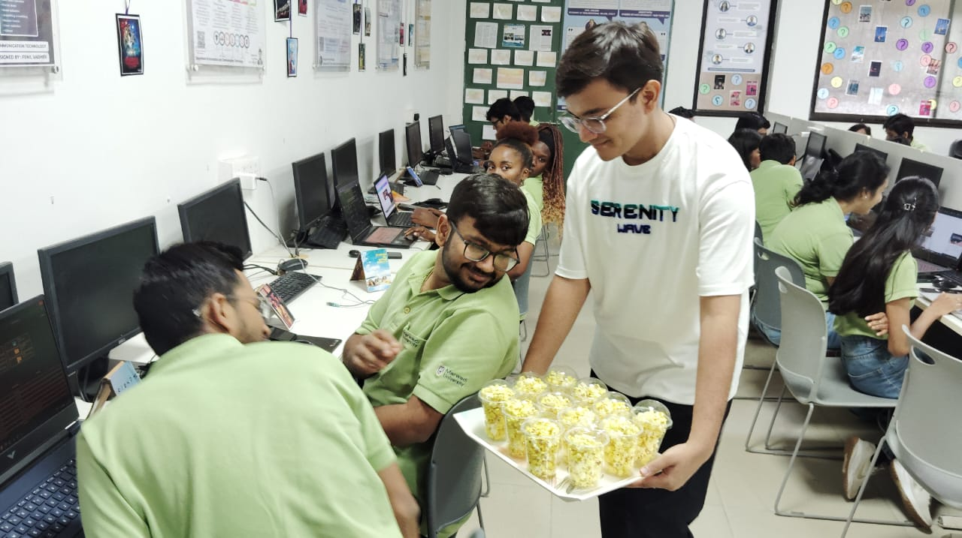

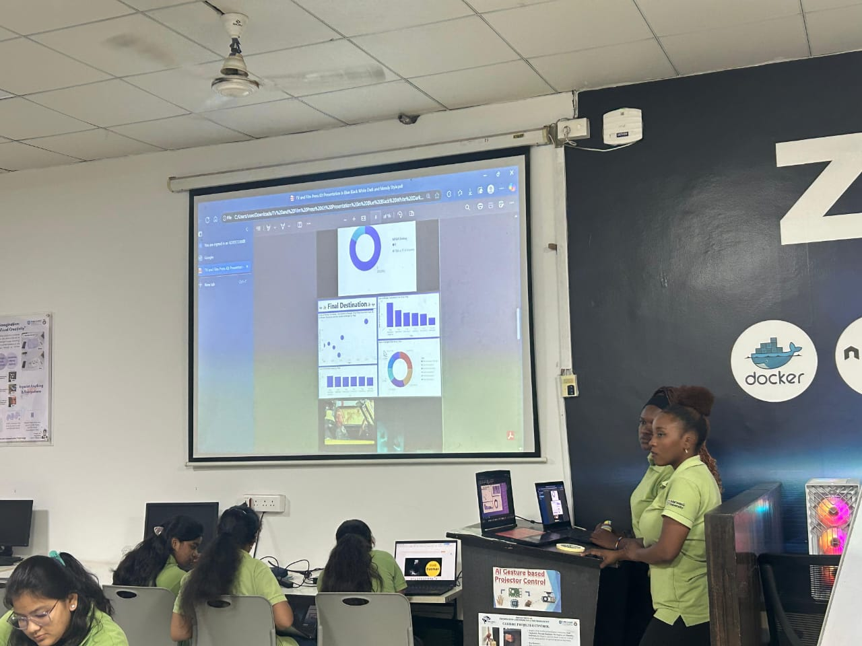

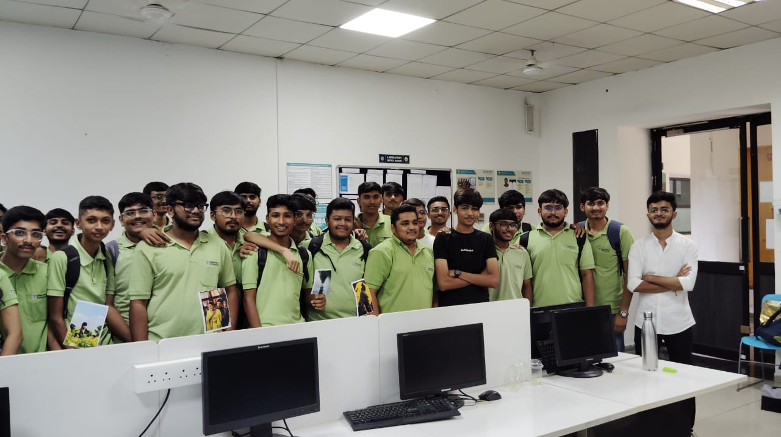

Winners of Dataflix Event :
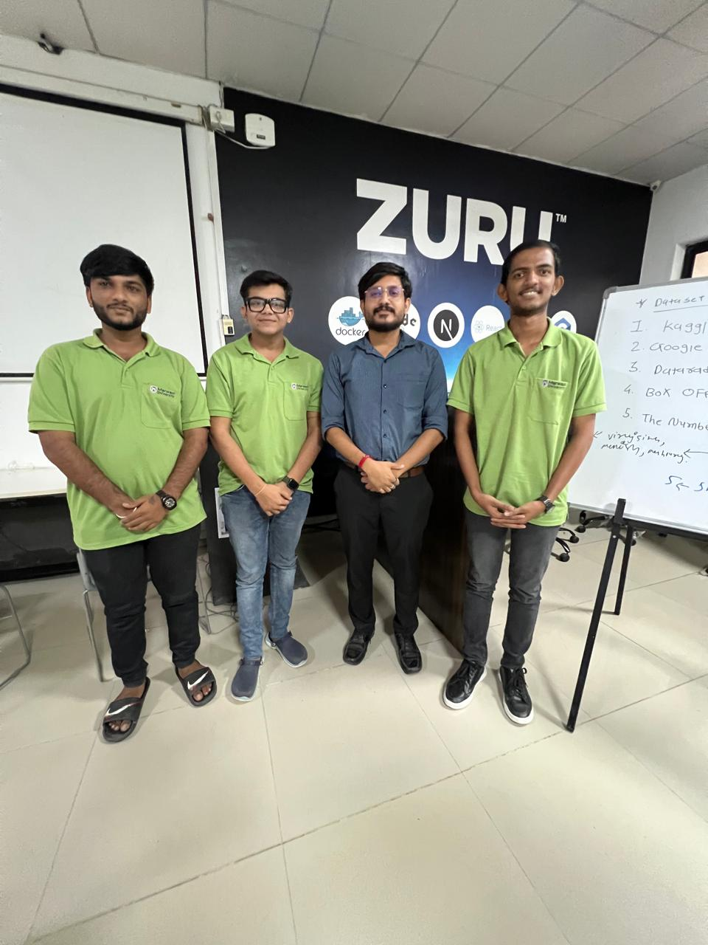
Rank 1:
Mungra jigar - 92510133048
Heet nathwani - 92510133052
Praneeth kumar -92510133037

RANK 2:
Yurica Silvana de Assis
Caetano:92301733008
VictoriaVedastus: 9230173305

Student Coordinators Of The Event :

- Rudra Miyani
- Hitarthi pansuriya
- Dhyana Kothari
- Akshat shah
- Vishant Chhaniyara

Fenil vadher (mentor)
Dhruvi bhalodia (mentor)

